

Introduction to Software Engineering

**Project: Baby monitoring system**

**Modeling and Design Report**

**Done by:**

| Saif Ahmed, | 100059926 |
| --- | --- |
| Obaid Saif, | 100059726 |
| Abdulla Husain Binmahfoudh | 100058593 |
| Abdulrahman Saleh | 100053528 |

Table of Contents:

1.0: Abstract

2.1: UML Case Diagram:

2.2: Sequence Diagram:

2.3: State Diagram Model:

3.0: Conclusion:

# Abstract

The sole purpose of this report is to display the design and modeling decisions for the Web-based Baby Monitoring System that is currently under development. This report will include various design and model figures to provide a better understanding for the reader about the system that is currently under development. Moreover, this report will include a user-case analysis that will describe the functional requirement of the Baby Monitoring System, a sequence diagram to better illustrate the system operation sequence.

# UML Case Diagram

This section of the report will include the Object model of the Child Monitoring System.

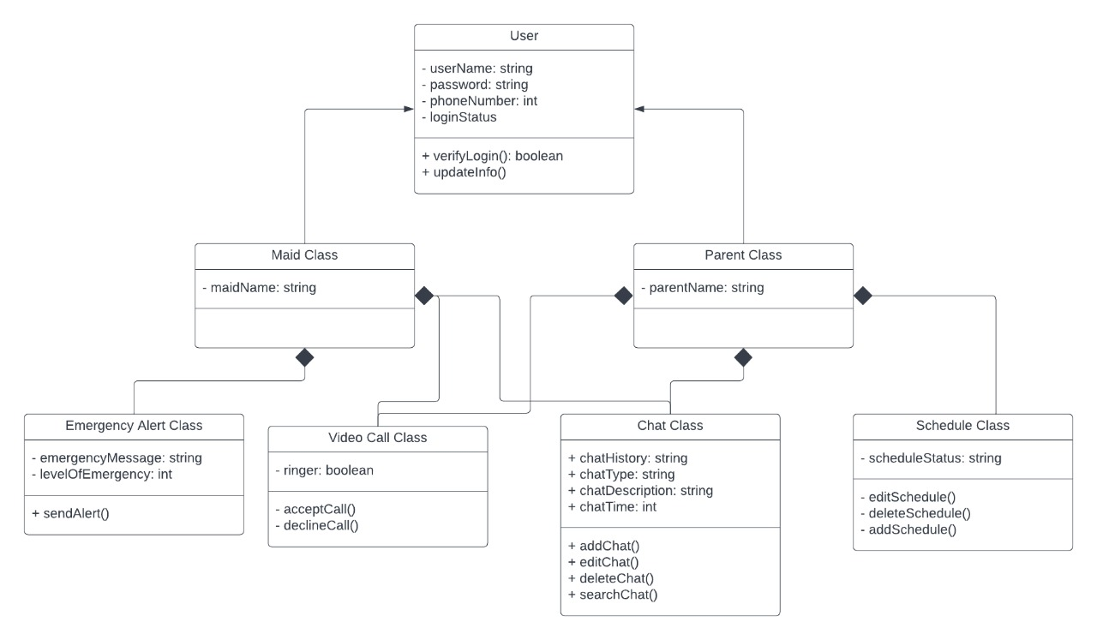

# 

# Sequence Diagram

This section of the report will include the Sequence diagram of the Child Monitoring System.

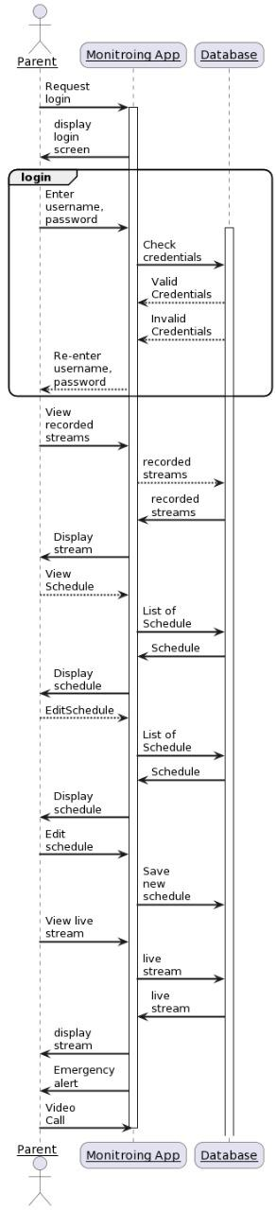

# State Diagram Model

This section of the report will include the Object model of the Child Monitoring System.

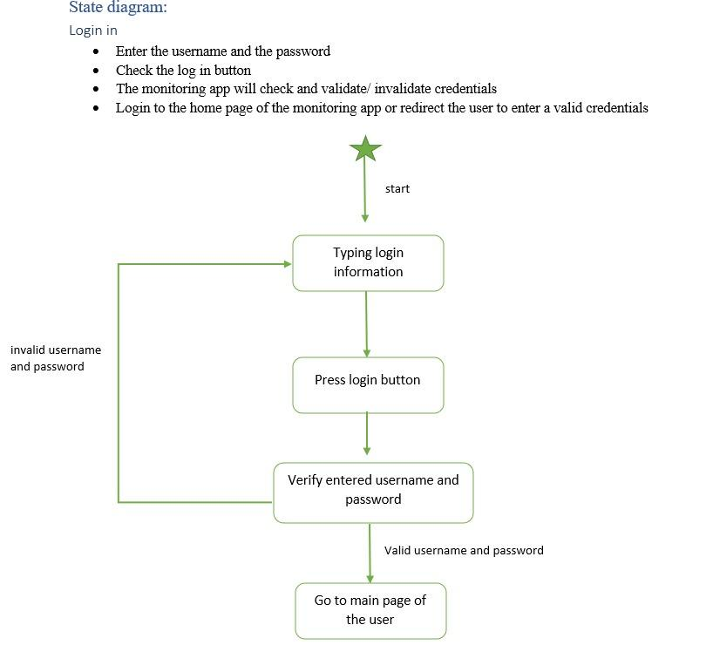

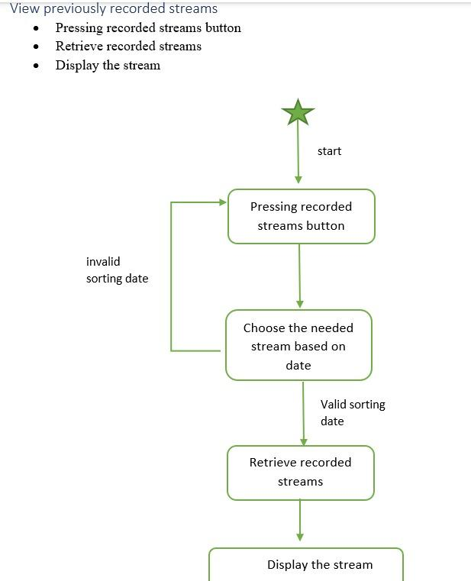

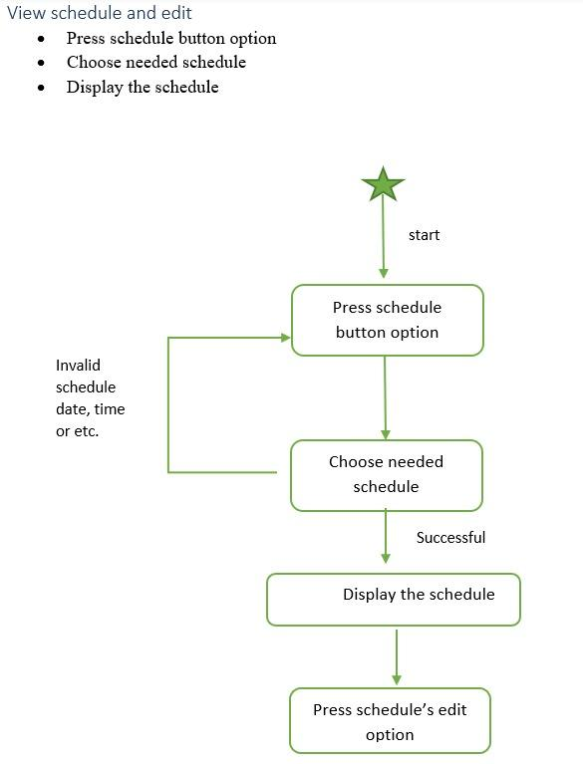

# Conclusion

To conclude, the aim of this report was to provide a better understanding for the Child Monitoring System that is under development. One important aspect when developing a system is to provide various Models for the client in a way that the client can understand how the system will be developed. These models include UML Class Diagrams, a sequence diagram that illustrates an instance of the system’s operation and State Diagrams. Each of these models are developed in a way for the reader to understand the functions of the system and its interactions.